**Week 5 Ex-9-Output**

**1. Create a Book(Spring HATEOAS) to display link:**

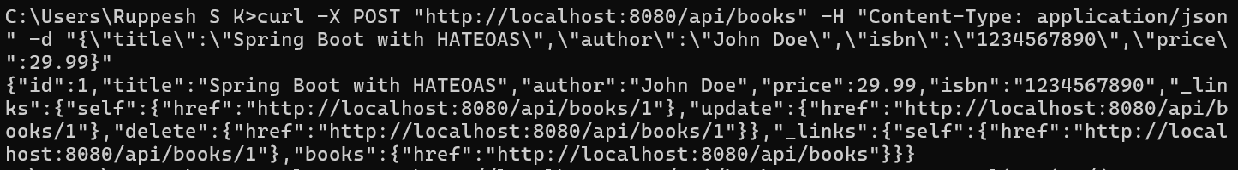

**2. Retrieving All Books:**

